**Neverrest**

**Sky is the limit**

**NO NAME:logo:logo.eps**

**Course 2 “Mobile Gaming and Sports”, Ferienakademie 2014**

Content

Game idea 2

Gameplay and features 2

Registration 2

Menu 3

Challenges 3

Single player challenges 3

Group challenges 3

Challenge Selection 3

Active Challenges 4

Badges 5

Player profile 6

Feedback Service 6

Structure 7

Tracking user activity 7

Current state of implementation 7

Outlook 8

Sources 8

# Game idea

The idea for Neverrest was created in the course 2 “Mobile Gaming and Sports” of Ferienakademie 2014.

The fundamental goal of the project is to encourage users, especially those who are beginners in sports, to be active and to form a long-lasting commitment to sports. They should have the possibility to overcome their own limits and gain self-confidence by being active. Another major goal is to facilitate teamwork and communication with other players, so the app also takes on a socializer function.

These goals were integrated in the idea of Neverrest: Players can explore the world and engage in challenges, for instance climbing the Mount Everest or running along the Route 66 virtually. To complete such a challenge, users do sports such as running, biking, or walking. By tracking the players via GPS, the covered distance or altitude difference is added to the challenge. Like this, users have an incentive to engage in activities regularly in order to accomplish big goals such as climbing the Mount Everest. There are also group challenges, where users can cooperate with others in order to tackle big challenges like the distance between the earth and the moon. Here, all group members work together to gather the distance needed to reach the goal. This should also encourage users to be active regularly in order to not let the group down, and perhaps real-life groups for sports can be formed through this feature, too.

# Gameplay and features

## Registration

On starting the application for the first time, users are asked to register. They can register with common social media logins such as Facebook or twitter, or they register with a separate login.

## *Macintosh HD:Users:monika:Desktop:Screenshots:Screenshot_2014-10-02-11-03-24.png*Menu

In the menu (see Figure 1), users can navigate between major features of the app. They can select the map, where they can choose new challenges, the player profile, the active challenges and the settings. The menu can be called by swiping from the left display fringe to the right.

## Challenges

The game’s core element is a selection of challenges. The player can tackle those challenges and is thus encouraged to contribute to them by doing sports in order to reach the challenges’ goals. There are single player challenges and group challenges.

### Single player challenges

The single player challenges are for one user alone. Players can add as many single player challenges to their list of active challenges as they want to, as long as it is not the same challenge twice.

For single player challenges, there are levels of difficulty. Players can unlock the next level by gaining about 75% of the sum of meters (of distance or altitude, for instance) of all challenges of the current level. Users can see a challenge’s level of difficulty in the challenge selection.

Figure : The menu

### Group challenges

Group challenges are challenges tackled by a group of players, and they are of bigger scale than single player challenges, such as the distance from earth to moon. Single player challenges cannot be played as group challenges. However, a single user can play a group challenge if the group only consists of one person. As these group challenges are large-scale challenges, this would take a long time for one person to finish, so users are encouraged to form teams and to cooperate with others.

Unlike single player challenges, group challenges do not need to be selected in the active challenge list before each activity. Instead, every activity automatically adds to the group challenge, if the measured value of the activity conforms to the measured value of the group challenge. For instance, an activity that measures the altitude for a single player challenge will automatically contribute to the group challenge corresponding to the altitude value, as far as a suitable group challenge has been added to the active challenges before.

Users can only enrol in one group challenge with the same measured value (for example distance) at the same time.

### Challenge Selection

The player can select challenges and add them to the list of active challenges. A player can add one particular challenge only once at the same time, so the same challenge cannot be in a player’s active challenge list twice.

***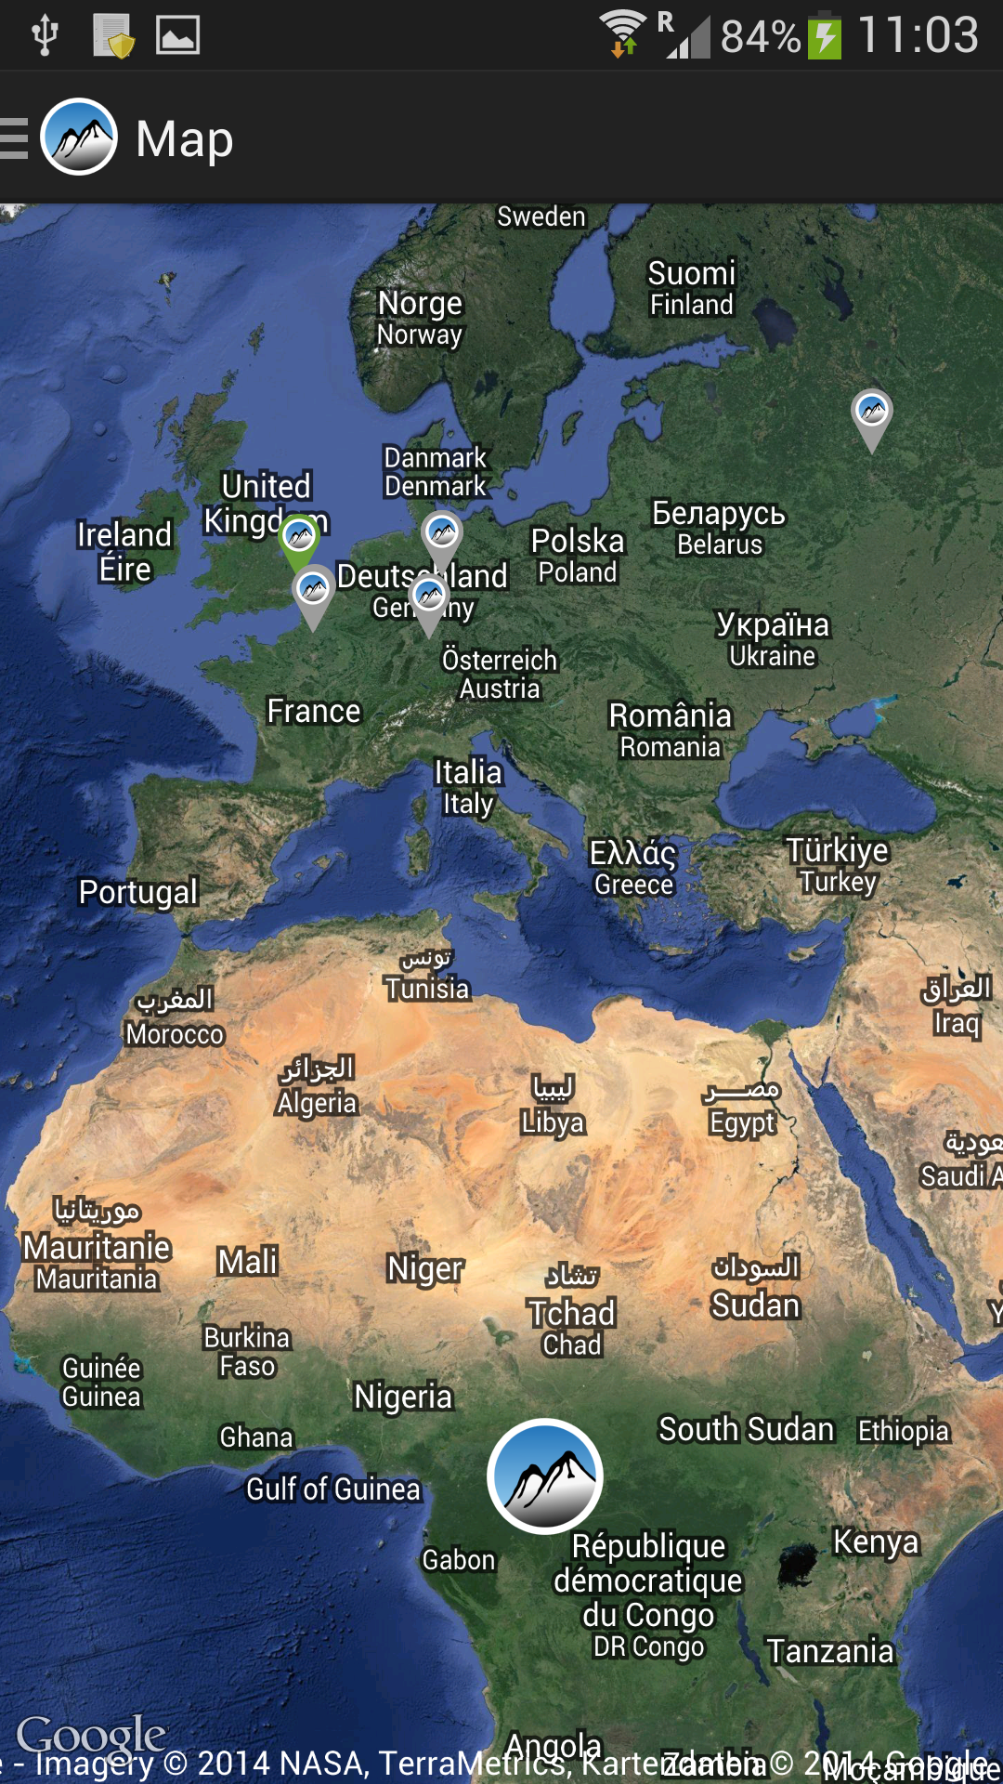***To add a challenge to the active challenges, users go to the map (see Figure 2) and select if they want to search for a single player or a group challenge. They can select a continent, and within this continent they select a country. In the selected country, the challenges are displayed. By selecting a challenge, users see more detailed information about it, and they can also choose to start this challenge. By doing so, the challenge is added to the list of active challenges. In the challenge selection, challenges are displayed in different colours depending on their status. If the challenge has not been started yet or has been cancelled, it is displayed in grey. If it is an active challenge, its colour is green. Already completed challenges are golden.

Figure : Map for challenge selection

### *Macintosh HD:Users:monika:Desktop:Screenshots:Screenshot_2014-10-02-11-23-02.png*

Figure : List of active challenges

### Active Challenges

The list of active challenges (see Figure 3) can be accessed via the menu by tapping on “Challenges”. By selecting one of the challenges in this list, users see more information on this challenge and, in the case of a single player challenge, they can start an attempt to contribute to this challenge with an activity (see Figure 4). If they do so, the next step is to select the activity they are going to do. Challenges with the same measured value can be contributed to with the same kinds of sports. For example, a challenge measuring distance can be done by walking, running, or biking. The users select which one of these they are going to do in their exercise. If the selection is complete, users start their exercise and see a screen with information on their performance.

While being active, users can take a break and later continue the activity.

When users end their exercise, they press “End stage” and receive information on their finished activity.

If a challenge is completed, the app gives a signal (sound and vibration) while the player is exercising. When the user ends the stage, the challenge complete screen shows the gained badge as well as detailed information on the completed challenge. Moreover, users get the opportunity to share the gained badge on popular social media.

If users continued their activity after the signal and then ended the stage after a while, they also see the challenge complete screen and on closing this they can choose if they want to start a new challenge with the additional meters, or add those meters to an already existing active challenge. If they decide to not add the additional meters to another challenge, they get to the menu. If they want to use the meters for a challenge, they will be shown the challenge selection.

The information on an active challenge (see Figure 4) contains the name, the measured value (see the icon in the upper left corner) and if it is a single player or a group challenge (see the player icon below the name). Furthermore, the total distance and the already covered meters are displayed, as well as a map view or a photo of the challenge, which gets more and more visible the farther the user progresses with the challenge.

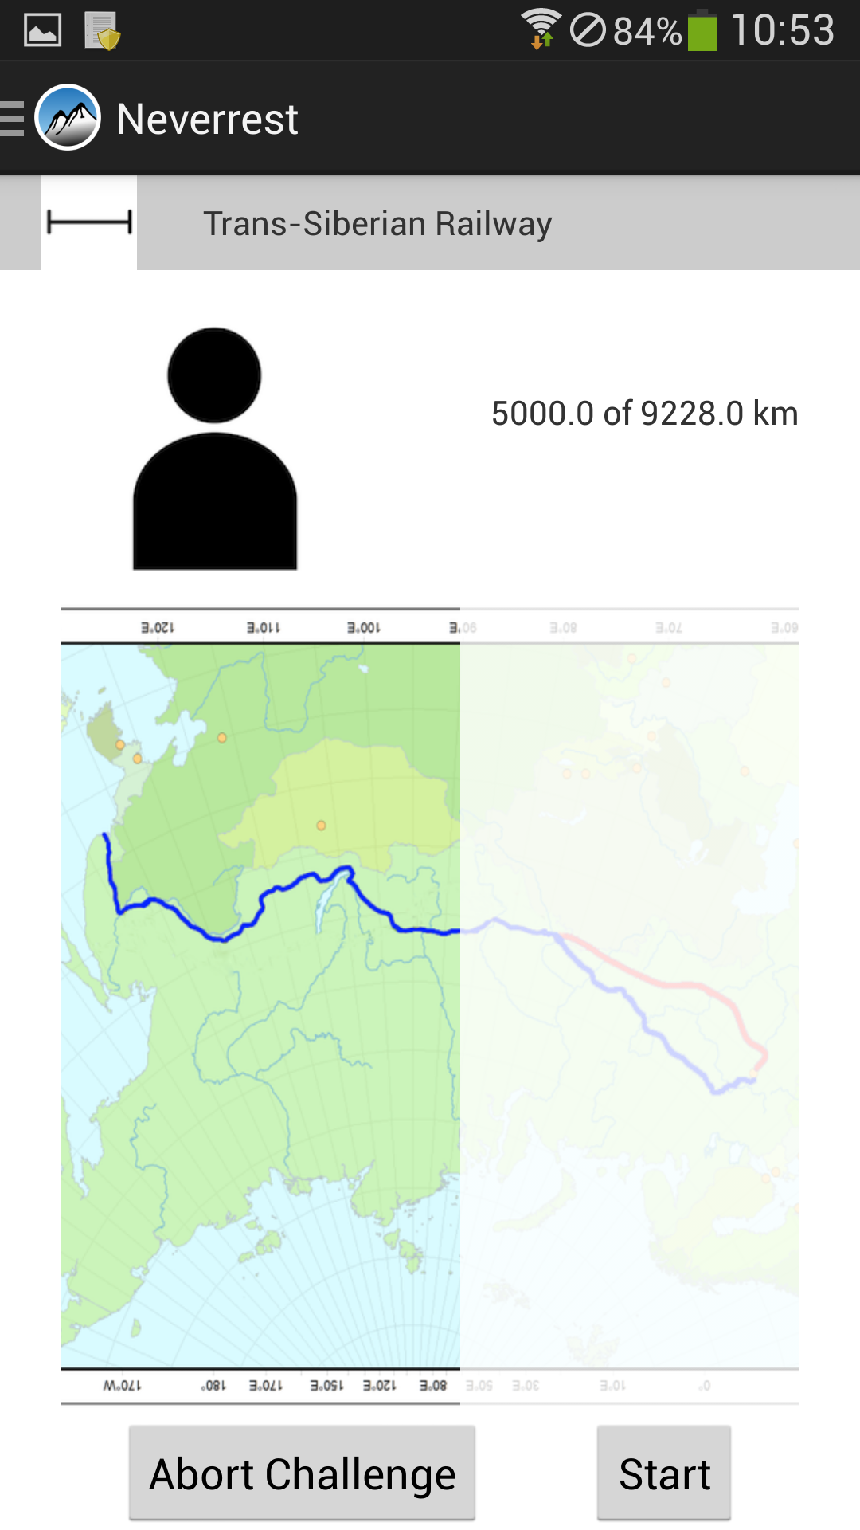Challenges can be aborted anytime by tapping on “Abort Challenge”, and the player’s progress for this challenge is lost in this case. The player can start a challenge again after aborting it.

Challenges have no time limit, so players can work on a challenge as long as they wish or they need to in order to complete it. However, the list of active challenges displays how many days ago the last activity contributed to a certain challenge. The number of days is written in a different colour depending on how long this is ago. Green indicates a short timespan since the last activity, and orange indicates that it is more than a week ago. Red shows that the last activity was more than 2 weeks ago and signals the users that they should be active again.

Figure 4: Challenge information

## Badges

Badges are gained for completed challenges. Furthermore, there are some badges the player can gain for other activities like inviting many friends to the app or meeting up with friends in person to do sports and contribute to challenges.

## *Macintosh HD:Users:monika:Desktop:Screenshots:Screenshot_2014-10-02-11-03-38.png*Player profile

Figure : Player profile (with dummy avatar picture)

The player profile stores information about the user and the progress in the game. There is an avatar that can be customized: The user can gain shirts, trousers and shoes for special achievements, or if a certain amount of friends have been invited to the app. Furthermore, the avatar looks fitter as the user is becoming more active.

The user’s name, sex, age, height and weight are also stored in the player profile. By tapping on this information, the player can edit it and save or discard the changes.

Furthermore, a list of the most recently gained badges can be seen. By tapping on this list, a complete list of all gained badges can be seen. In this list, users can select a badge and see more detailed information about the corresponding completed challenge.

The total distance and altitude the user has covered until now in all activities are also displayed in the profile. By tapping on these values, a diagram appears which shows how much of the distance was covered by doing which kind of sports.

## Feedback Service

After finishing an activity, users receive feedback on their performance. This includes the burnt calories as well as the amount of lifetime they have gained by being active. The additional lifetime is calculated based on a study by Moore et al. from 2012[[1]](#footnote-1).

# Structure

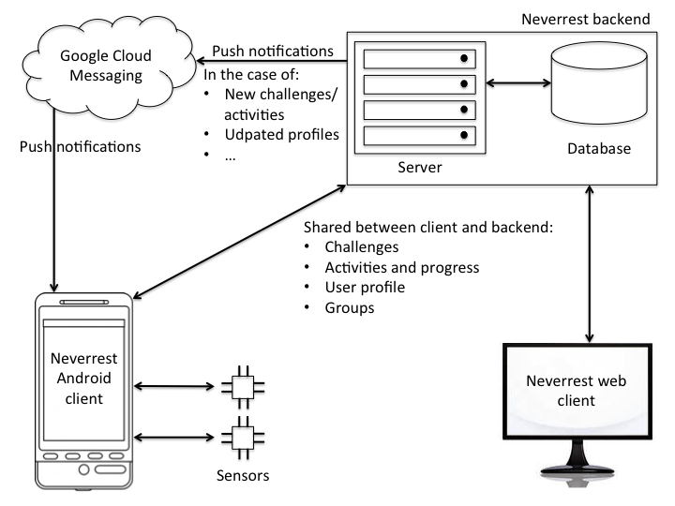

The figure above shows the structure of the app’s client server system. The app can be used on both Android clients as well as web clients. Both types of clients communicate with the Neverrest backend, which consists of a server and a database. Clients and backend share the challenges, activities and the progress in those, user profiles and groups. Android clients moreover receive data from sensors. These clients also receive push notifications from the backend via the Google Cloud Messaging service whenever changes have been made.

## Tracking user activity

We use GPS to track the users’ activity and thus measure the covered distance or altitude. Sensors that can be used to receive information about the users’ activities are the inertial sensors of smartphones and heart rate sensors.

# Current state of implementation

The application is in the stage of a prototype at the moment. Basic features such as the GPS tracking and the challenge selection via world map view are basically implemented, but some other features are still missing. Thus, the application is not yet playable for users, but can be presented as a prototype to show the concept and some basic features.

Major points that were left out due to a lack of time are the server, the use of the Google Cloud Messaging service, the targeting of web clients, and the group challenges. The latter includes not only the challenges themselves, but also the implementation of a way to connect and communicate with other users. This aspect is crucial to the app’s goal of communication and cooperation between users.

The registration is also not yet implemented, as well as a connection to social media, so users cannot yet share their game progress.

Currently, the only way to measure users’ performance is GPS tracking. Smartphone sensors or other sensors are not used yet.

# Outlook

In order to complete the app, some major features and some smaller ones need to be added. The missing basic components are mentioned above (see “Current state of implementation”).

Some smaller features that should be added in order to improve the gameplay are the avatar customization and the changing of shape by the avatar with increasing user activity. In the player profile, the diagrams, which show how many meters were covered by what kind of sports, should be added to provide more detailed information to users.

The adding of additionally covered meters to other challenges upon challenge completion also still needs to be implemented.

Furthermore, the signal for the completion of a challenge is not added to the project yet. In order to make the game more fun, more challenges should be included, and the level system still needs to be implemented.

More kinds of sports, such as swimming or weight lifting, can be included to broaden the gameplay experience.

# Sources

The pictures we used for the application are from the following sources:

Reinhard Dietrich [re-li], Azahan, Manfred Zentgraf/Flominator, Shuetzm, US 66 rough, Vzach, High Contrast, Longhair + James Northfield, Peter Rejcek/Ratzer, Infratec, Muns, d.wine, Polizeiruf/A. Gutwein, Nicke L, Flickr/Hank Leclair, [¡0-8-15! / Fanoftheworld](http://commons.wikimedia.org/wiki/User:%C2%A10-8-15!), Fry1989/Washiucho, CathLegrand, Flamurai, Frickr/Warren H, Holger Weinandt/Schängel, Kristel.kitsing, Raimond Spekking/CC BY-SA 3.0, Hcii, Smial, Mario Roberto Duran Ortiz, Yosemite, Luca Galuzzi, Troy Thomas, Kauk Or, Andrew Bossi, Dirk Bayer, Matthieu Riegler, Friedrich Böhringer, Prankster, lain99, Axel Hindemith, Dysmachus, M. Kübler, Otberg, Arne List, Robert Raderschatt

1. Moore SC, Patel AV, Matthews CE, Berrington de Gonzalez A, Park Y, et al. (2012) Leisure Time Physical Activity of Moderate to Vigorous Intensity and Mortality: A Large Pooled Cohort Analysis. PLoS Med 9(11): e1001335. doi:10.1371/journal.pmed.1001335 [↑](#footnote-ref-1)